# Exp no;10

# Simple programming exercise using(REPEAT, WHILE )

**Questions:**

1.Display the faculty names whose salary IS NULL.

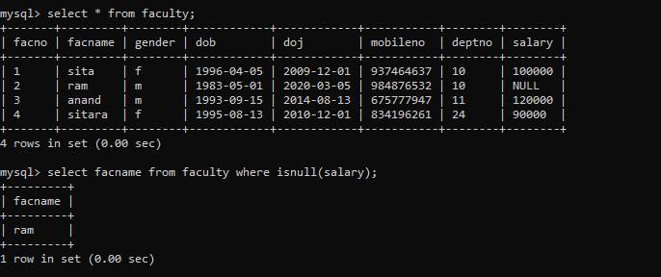

2. Display the salary of all the faculty. If null salary it should be displayed as 0

